**DEPARTMENT OF INFORMATION TECHNOLOGY**

|  |
| --- |
| NAME: Ayush Vinod Upadhyay  ROLL NO: I025  SAP ID: 60003220131  BRANCH: Information Technology  BATCH: 1 |

# EXPERIMENT NO. 9

**CO/LO:** Develop web applications.

**AIM / OBJECTIVE:** Program based on inbuilt functions in Node.js.

**Task 1: Working with File System**

1. **Reading a File:**
2. const fs = require('fs');
3. fs.readFile('sample.txt', 'utf8', (err, data) => {
4. if (err) {
5. console.error(err); return;
6. } console.log(data);
7. });



**2. Writing to a File:**

const fs = require('fs'); fs.writeFile('output.txt', 'Hello, Node.js!', (err) => {

    if (err) {

        console.error(err);

        return;

    } console.log('File written successfully!');

});



**3. Checking if a File Exists:**

const fs = require('fs');

fs.access('check.txt', fs.constants.F_OK, (err) => {

    if (err) {

        console.error(err); return;

    } console.log('File exists!');

});



**Task2: Handling HTTP Requests**

1. **Creating a Basic Web Server:**

const http = require('http');

const server = http.createServer((req, res) => {

    res.writeHead(200, { 'Content-Type': 'text/html' });

    res.end('<h1>Hello, World!</h1>');

});

server.listen(3000, '127.0.0.1', () => {

    console.log('Server is running on http://127.0.0.1:3000/');

});



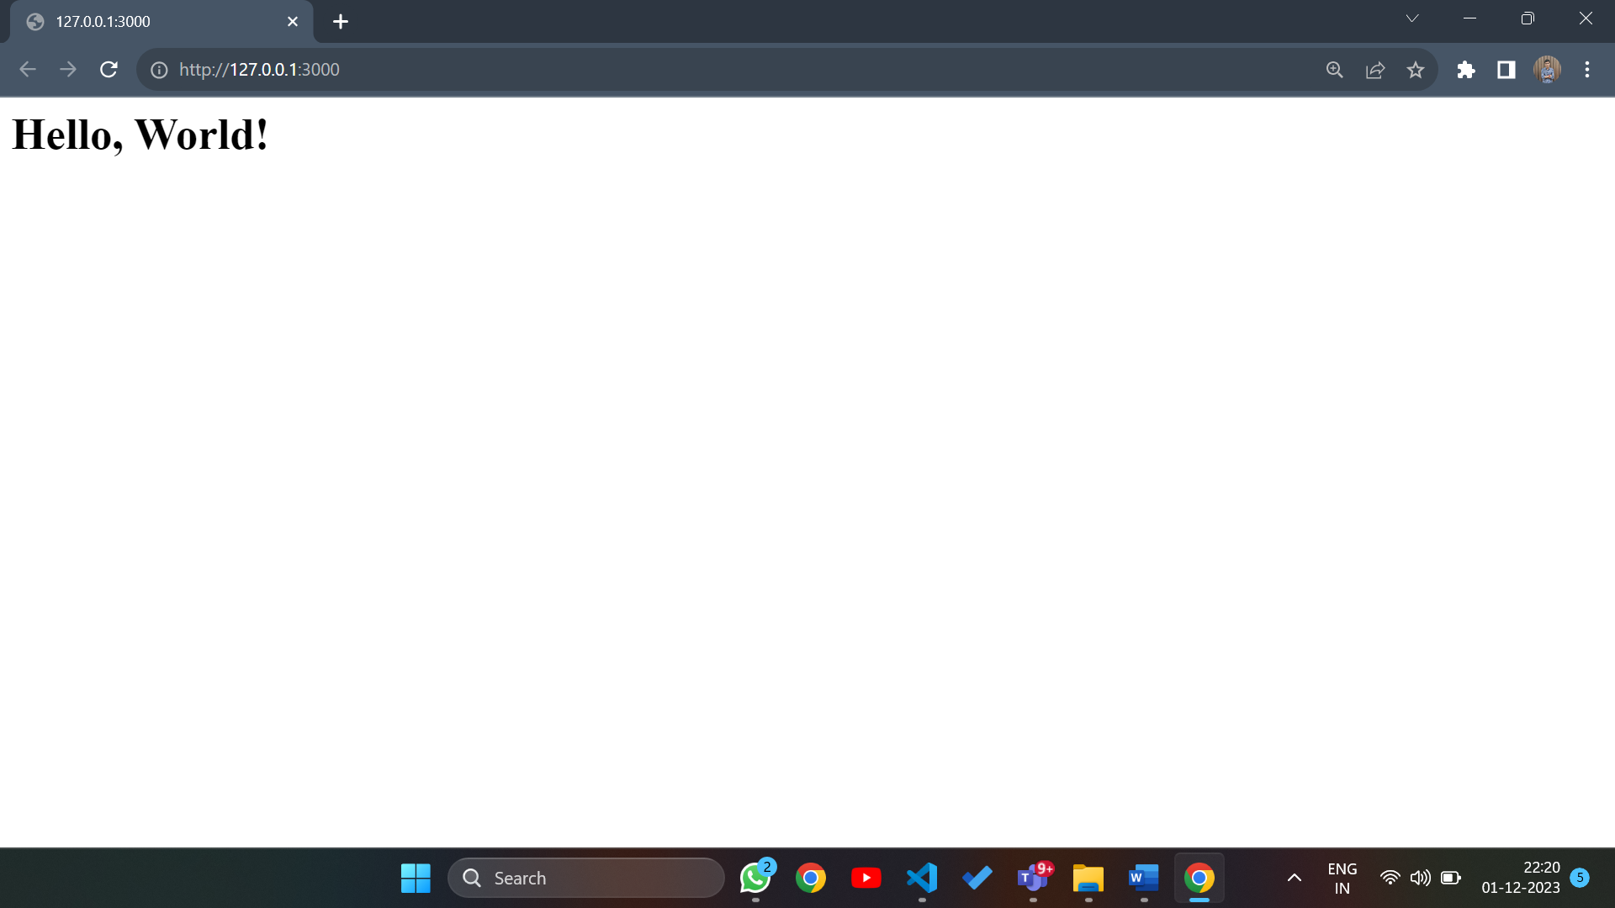

1. **Sending an HTTP Request:**
2. const http = require('http');
3. const options = {
4. hostname: 'api.coindesk.com',
5. path: '/v1/bpi/currentprice.json',
6. method: 'GET',
7. port: 80,
8. };
9. const req = http.request(options, (res) => {
10. let data = '';
11. res.on('data', (chunk) => {
12. data += chunk;
13. });
14. res.on('end', () => {
15. console.log(data);
16. });
17. });
18. req.on('error', (e) => {
19. console.error(`Problem with request: ${e.message}`);
20. });
21. req.end();

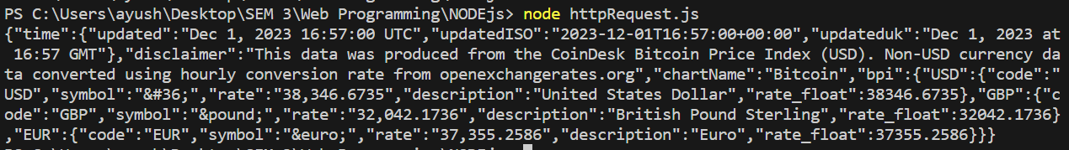

**BOOKS AND WEB RESOURCES:**

1. Tailwind CSS From Scratch | Learn By Building Projects by Brad Traversy
2. Tailwind CSS: A Modern Way To Build Websites Using CSS

**CONCLUSION:** I learn**ed** about file System module and implemented http requests.